**Sales Project in SQL**

1. **Total Revenue**

select round(sum(total_price),2) as Total_Revenue from pizza_sales;

**Output**

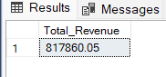

1. **Average Orders**

select round(sum(total_price)/ count(DISTINCT order_id),2) as Avg_order_value from pizza_sales;

**Output**

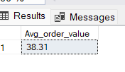

1. **Total Pizza Sold**

select sum(quantity) as Total_pizza_sold from pizza_sales;

**output**

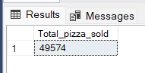

1. **Total Orders**

select count(distinct(order_id)) as Total_orders from pizza_sales;

**output**

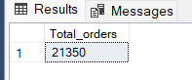

1. **Average Pizzas order per order**

select cast(cast(sum(quantity) AS decimal(10,2))/ cast(count(distinct order_id) AS decimal(10,2)) AS decimal(10,2)) as Avg_pizza_per_order from pizza_sales;

**output**

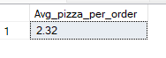

1. **Daily trends over order**

select DATENAME(DW,order_date) as Order_day, count(distinct order_id) as Total_orders

from pizza_sales

group by DATENAME(DW,order_date);

**output**

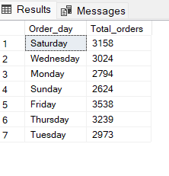

1. **Hourly Order Rate**

--Hourly Trend

select DATEPART(HOUR,order_time) as Order_hour, count(distinct order_id) as Total_orders

from pizza_sales

group by DATEPART(HOUR,order_time)

order by DATEPART(HOUR,order_time);

**Output**

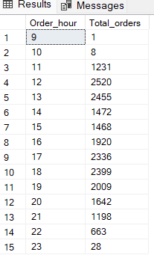

1. **Total Sales**

select pizza_size,sum(total_price) *100/ (select sum(total_price) from pizza_sales where MONTH(order_date)=2) as Total_sales

from pizza_sales

where MONTH(order_date)=2 --2 indicated month ie Feb

group by pizza_size;

**Output**

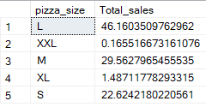

1. **Pizza Category**

select pizza_category, sum(quantity)as Total_Pizzas_sold

from pizza_sales

group by pizza_category;

**output**

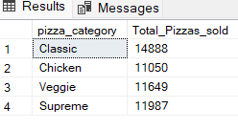

1. Top 5 Pizza’s sold

select TOP 5 pizza_name, sum(quantity) as Total_pizza_sold

from pizza_sales

group by pizza_name

order by sum(quantity) desc;

**Output**

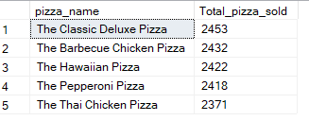

1. **Bottom 5 or less sold pizza’s**

select TOP 5 pizza_name, sum(quantity) as Total_pizza_sold

from pizza_sales

group by pizza_name

order by sum(quantity) ASC;

**Output**

